**Ntier on Azure**

* We need to create the following network  
  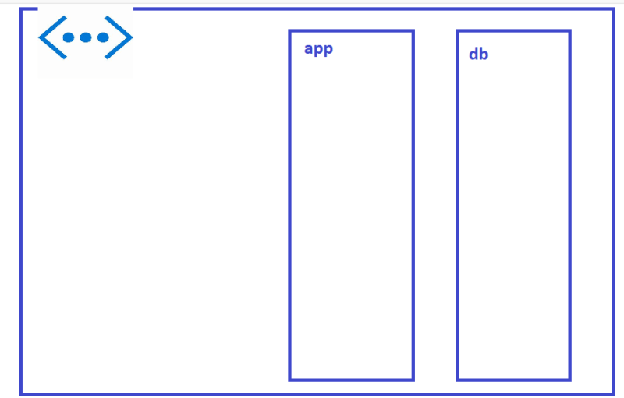
* replaced hardcode names for resource group and vnet with variable <https://github.com/asquarezone/TerraformZone/commit/9959f23b5c4ee8b9fb993748803c3c872b1af061> for the changes  
  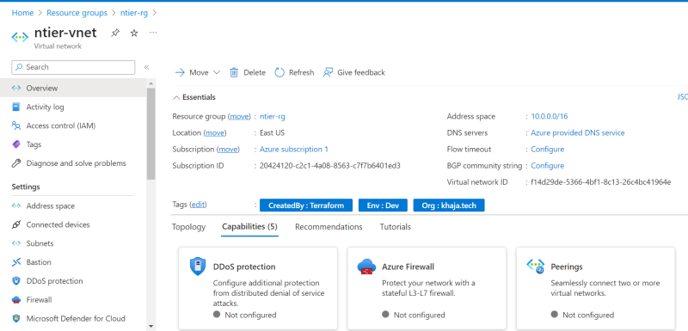

**Let’s try to Create Azure SQL Database**

* Manual steps: <https://learn.microsoft.com/en-us/azure/azure-sql/database/single-database-create-quickstart?view=azuresql&tabs=azure-portal>
* We need to Create SQL Server and then database
* <https://github.com/asquarezone/TerraformZone/commit/5f2bf9efefacefd6712deb72c2624b380ba2970f> for the changes done to create sql server
* Execution and Database creation are pending

# How to manage multiple environments with Terraform We create input.tf file where we define variable with default values, and we can create environment specific file like dev.tfvars , qa.tfvars and prod.tfvars to overwide existing variable.

What happen when you run the terraform destroy/apply command? In terraform we have configuration present in 3 places- 1) Cloud provider, 2) statefile and 3) main.tf

At first terraform destroy command run internally terraform refresh command which get latest data in statefile. Later on, it compares statefile and main file configuration, and generate plan.

What are the 3 places where tf configuration is present: 1) Cloud provider configuration, 2) statefile[local configuration] 3) main.tf file.

What 3 command internally run when we run tf apply or destroy command? Terraform refresh, terraform plan and terraform create.

What happen when we run tf plan command? Terraform plan command first run terraform refresh to get latest infrastructure details from cloud provider, later on it compare changes with main.tf file and generate plan what to do.

What is –auto-approve means? It means terraform directly execute the plan.